**Report For Construction of a Competitive national football team for Rarita**

**The University of New South Wales**

**Team Cool**

**YIXUAN WANG**

**WENYAN REN**

**BIHAN SHEN**

**YIFAN XIAO**

**YIFAN LI**

Table of Content

Objectives2

Team Selection2

Structure of the national team2

Data manipulation2

Entropy weighted method2

Modelling and team selection3

Expected revenue and expense5

Expense5

Revenue6

Net profits6

Economic Impact6

Impact of direct operating profit/loss on GDP per capita 6

Impacts on other industries7

International impact and net export7

Implementation Plan8

Assumptions9

Risk and Risk Mitigation Considerations9

Data and Data Limitations10

Data used 10

Data Limitation 10

Appendix12

Team Selection 12

Data preparation and modelling12

Missing values12

Feature selection and preparation13

Standardized formula13

Entropy weighted method14

Expenses and revenues 14

NPV of net income 16

**References18**

**Objectives**

Football has been a heavily watched sport worldwide and the success of the national soccer team can bring positive effects on a country’s economy. The international Football and Sporting Association (FSA) champions were awarded with money and champion countries used part of it to develop sports industry for example investing in sports arenas and leagues. In addition, because the FSA gets increasingly more attention in the world the winning countries’ global visibility enhances; it attracts many new investments, develops the national tourism and political influence hence accelerating the economic growth. To catch the benefits from it, we plan to construct a “competitive” national soccer team for Rarita which aims to become top 10 members of the FSA in the next five years with relatively high probability of being an FSA champion.

In addition, we will analyze the potential economic influence of building a such “competitive” national team and the football “brand” on economy of Rarita over the next ten years. Furthermore we will also discuss the implementation plan and monitoring plan. To make the plan more reliable we will do risk analysis and recommend some risk-controlling measures.

**Team Selection**

**Structure of national team**

First, Rarita needs 25 footballers to build a formative national team, including 11 starters and 14 substitutes. In each match, the manager is free to change the players and to change the tactical arrangements with the approval of the referee. Therefore, each player on the national team roster has an important role to play.

**Data manipulation**

Consider the level differences between league and tournament games, player’s performance measurement under league and tournament are expected to be different. Hence, we suppose that choosing players from league data directly refer to modelling from tournament data could lead to a highly inaccurate result. Besides, there are players play both league and tournament games and we assume that the players have analogous performance in both games. Therefore, it is reasonable to standardize both league and tournament data for further analysis.

**Entropy weighted method**

The players in different positions focus on different performance metrics, such as forward generally need better performance in shooting and passing rather than defense. Therefore, we separate 4 original metrics into 7 independent metrics based on positions (Forward: shooting, passing; Midfielder: passing, defense; Defender: defense, passing; Goalkeeper: goalkeeping). Furthermore, there are numerous minor measurement features in each main metric which could significantly increase the model complexity. Also, our team are lack of experiences in soccer which the subjective weighted methods are not suitable in this case. Thus, we applied Entropy Weight Method (EWM) to determines the objective index weight for each minor measurements according to the dispersion degree and calculate an overall score for each major metric. Moreover, since the success of soccer team is based on the performance of every player, therefore, we take the average score for each team by position for further analysis instead of solely considering the personal performance.

After the data manipulation procedures, the dimension of measurement for each nation are reduced to 7 variables that explain the tournament rank:

**Modelling and team selection**

Rather than directly choosing players from league data based on scores, we did regression analysis in advance to discover the relative significance of scores for each position on the overall rank. As we are most interested in success rate of achieving top ten FSA members we replace the rank by 1 and 0 with 1 indicates success and implement logistic regression to derive success rate. The relative significance of variables is based on AIC stepwise selection and retain at least one measurement for each position. In addition, we checked the feature importance by random forest method which also provide a similar result on variable significance. The variables chosen for modelling are ShootingFW, PassingFW, PassingDF, DefenseMF, and GoalkeepingGK where ShootingFW is the most statistically significant. Through comparison of accuracy the logistic regression was chosen.

The selection of Rarita team is generally based on scores of ShootingFW, PassingDF, DefenseMF, and GoalkeepingGK for corresponding positions. We choose the players with top 5% scores in league from Rarita and then hire top players from other nations if there are insufficient players in the team.

Expected probability of success for team Rarita in 2022 based on current performance is 69.44%. Assume the relative competitiveness of team Rarita retain the same level in the future, the probability of achieve top ten for at least three times within 5 years will be 82.94% with 95% confidence interval at [74.62%, 91.26%].

**Expected Revenue and Expenses**

We analyzed the spending required to support a “competitive” national soccer team and direct team revenues that are expected be generated from such a national team. Because Rarita has no any previous experience in building a national team we investigated related information of other countries which ever were top 10 in tournament, Rarita’s historical revenue/expense without the national team and inflation factors[1] to predict Rarita’s national team’s spending and revenues.

1. **Expenses**

Expenses of assembling a competitive national team mainly contains the staff costs, which includes salaries to football players[2], technical staff, medical staff and administrative staff, and other expenses like facility management fee and rent of pitch. It worth noting that after subtracting the part of expense not directly related to the national team the expenses (per Capita)[3] in employing foreign players (i.e. salaries and borrowing fees) were added. Furthermore, by considering the lack of experience of Rarita in building the national team we added a 10% loading to first three years’ staff costs and other expenses.

1. **Revenues**

Direct revenues from having a competitive national team consist of matchday revenue, broadcasting revenue and commercial revenue. Matchday revenue mainly represents the portion of revenue generated from staging of matches such as ticket sales. Broadcasting revenue includes the revenue earned by attending domestic leagues, cups and international competitions. Besides, commercial revenue contains the part of revenue generated from commercial operations such as merchandising and sponsorship. After remove the part of revenue generated from sections other than the national team we furtherly adjusted team revenues of initial three years to lower values because of consideration of transition and the gel of the new national team.

1. **Net income**

Initial losses existed for first three years after construction of the national team. In addition to ∂ 995000000 of Rarita’s one-time fund the team still needs the fund of ∂305836631.64 to cover these excess expenses. A six-year loan can be made in 2022 to raise the capital needed. Consequently, the net present value of net incomes generated by the national team from 2022 to 2031 is about **∂** 495443295.16 (Appendix, team selection 3).

**Economic Effect**

**Impact of direct operating profit/loss on GDP per capita**

By considering the profit and loss of Rarita for 2022-2031, we can find out the direct influence of the operating profit/loss of Rarita on the expected growth rate of the GDP per capita will be small (figure 2.7). However, potential impacts of construction of a competitive national team on Rarita’s economy and society should be the main considerations.

**Impacts on other industries**

If the national soccer team we constructed is a competitive team, which means it reaches the top 10 in FSA, the impact that comes from being competitive will certainly boost other related industries, such as local tourism, manufacturing of sportswear and equipment, online broadcasting, and media industry. And the development of local tourism for example will also promote construction of the national infrastructure, increasing government spending as a result. Besides, a successful and famous national soccer team will not only boost related consumption to stimulate short-term economic development, but also directly create jobs in both the soccer industry and related industries, thus reducing the unemployment rate to some extent.

**International impact and net export**

It seems no exaggeration to say that excellent national sports results can enhance international influence of a country to some extent, which is also a reflection of comprehensive national strength. A country with stable economic development and high international influence is relatively less at risk of capital flight than a country with political instability. Furthermore, countries with the high international influence will also increase the awareness of their products and the trust of more foreign investors and customers. Hence, having a competitive national team will not only help to attract capital inflows and reduce the risk of capital flight but also enhance the recognition of domestic goods in the international market. It undoubtedly will increase the national net exports hence affecting Rarita’s economy positively.

**Implementation Plan**

**Timeline**

**2022: do the preparatory work**

Team selection:

Rarita’s national football team will select 8 loaners from 6 countries, and the total expense which includes the players’ salary and the lending fee is ∂19,125,600. Also, 17 homegrown players will be picked in the Rarita squad.

At the same time, Rarita needs to make a six-year loan (∂305,836,631.64) from private funding sources to cover the excess spending.

**2023-2027: participate and get the qualification**

No change in the team selection and keep monitoring the results (win percentage, the players' statistic)

Source of revenues (for next ten years):

First, the gate receipts and licensing are the most basic source of income, accounting for approximately 15%, and catering sales on the matchday can also increase the revenues.

Second, the broadcast revenue is the key to improving the national team’s profit. According to the prediction, teams make 40% of their money by selling rights to broadcast the Football Games. If the Rarita national team has an outstanding performance, they will receive a hugely disproportionate share of the televising revenues. Because of the power of football, the TV revenue is relatively stable to afford the team overhead.

The third category is the commercial income, including advertising endorsement, franchise, sales of peripheral products, corporate sponsorship and so on. This part of the revenue is the most closely correlated with the ranking in FSA and the popularity of the players. More sponsorship can be attracted by the excellent performance so that the team will obtain more revenue in this part.

**2028: repay the loan**

The team will pay back the principal and the interest (∂55,114,318.9) on the loans (∂360,950,950.56) at the end of this year.

The extra and the most surprising income is the prize money from the international Football and Sporting Association, which will also show that our national team is competitive on the world side.

**2029-2032:**

Keep monitoring (revenue and growth on GDP) and lend the substitutes to other countries, if possible, to achieve extra revenue

 The key metrics:

1. The win percentage and the ranking, which directly represents the strength (twice a year)
2. The players’ statistics which can help the coach team to adjust. (twice a year)
3. Occupancy rate and audience rating (once a year)
4. The actual revenue/expense and compare with the expected one (once a year)
5. The growth in GDP (once a year）

**Assumptions**

* Metrics in players’ data is regarded as standardized values with a “special” method. We regarded some “negative” metrics as indicators of “extremely” bad performance;
* Assume that players employed by other countries which attend tournament are all local players hence their football-soccer expense does not include foreign players’ salaries.
* Purchasing Power Parity theory. Assume that Rarita’s currencies should have the same purchasing power with other currencies after adjusting for exchange rate- i.e. prices of the same goods/services should be equal when they are expressed in Doubloons.
* Assume that the outflow of expenses and the inflow of revenues are at end of each year;
* Discount rate – 4.45%
* The average rate for nominal spot rates of risk-free bonds mature in 2032 which is higher than that of earlier maturity hence being more conservative.
* Annual percentage rate for 6-year loan - 2.8%
* The average of nominal risk-free rate for the maturity of 6 years during the year 2010-2020

**Risk and Risk Mitigation Considerations**

**Biased data**

In the team selection, a few foreign players are eventually selected for the team. There has been a concern about data sets for foreign players, where the information of best players could be hidden or changed by their countries rather than exposed to the public. The issue can cause an overestimation of the competitiveness of our team.

Mitigation: Obtain player information from multiple channels and keep track of the competition.

**Misjudged expense**

This is the first time to establish a national team. Detailed dimensions for historical expense data are not provided, so whether there is an extra budget for training before competition is unknown. The first attempt at this challenge may cost more than expected.

Mitigation: Add 6% loading to extreme scenario.

**Sensitivity test of risk-free rate and discount rate**

* For discount rate, the NPV of net income would be within 10% of the projection if it is within (1.47%, 7.63%)
* For risk-free rate, the NPV of net income would be within 10% of the projection if it is within (0%,5.65%)
* The choices of risk-free rate and discount rate can influence the projected NPV for the national team over 2022-2031. There is about a range of ∂118M in the NPV by varying the discount rate between 1.5% and 7.5%. There is about a range of ∂121M in the NPV by varying the annual percentage rate between 1% and 6%.

**Data and Data Limitation**

**Data used**

* Player data which contains both league and tournament player statistics on four aspects’ performance metrics (i.e. shooting, passing, defense and goalkeeping) and tournament results in 2020 and 2021.
* Football-Soccer revenue and expense for 21 countries;
* Economic data of Rarita including GDP, Population, risk-free rate, and inflation rate

**Data Limitation**

* **Lack of data**

1. **Players data**

There are no data for players’ performance metrics on passing and defense for 2020 Tournament. Although there are some shooting performance data for 2020 tournament a large proportion of missing value existed for some metrics (e.g. 100% missing in Standard Dist). For 2021 tournament, there are only 24 countries’ players data were provided. These make our construction of model be more difficult.

1. **Revenue/expense**

There is no information of other national teams’ construction which brings the difficulties in projection of national team expenses and revenues based on other countries’ data.

* **Unusual data**

There is a large proportion of data in performance metrics have an “unusual” values for which we are not sure if collectors used some “unique and special” standards. For example, the negative standard Sh/90 which should be positive in the real world however we do not know if a negative value is a wrong data or it represents a bad shooting performance. Because “unusual” values occupies a undenied proportion removing or changing them directly may be risky( about 20% for some metrics). Such unusual data make our cleansing difficult and increases uncertainty of our results.

**Appendix**

**Team selection**

1. **Data preparation and modelling**
2. **Missing values**

To build the model to help us select team we mainly use the tournament information (which has the results) provided. We found that defensing and passing data only include the information of 2021 tournament. Although there are some 2020 data of shooting performance however there exists high proportion of missing for some metrics (e.g. Standard Dist has 100% of missing) therefore we only use data for 2021 tournament to build model in this project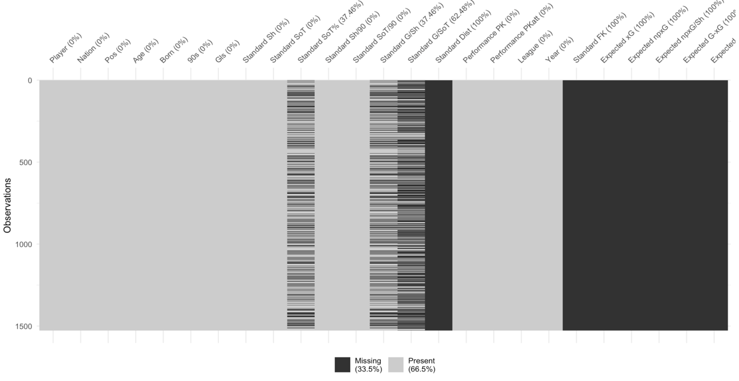

*Figure 8.1: plot of missing for Tournament shooting 2020*

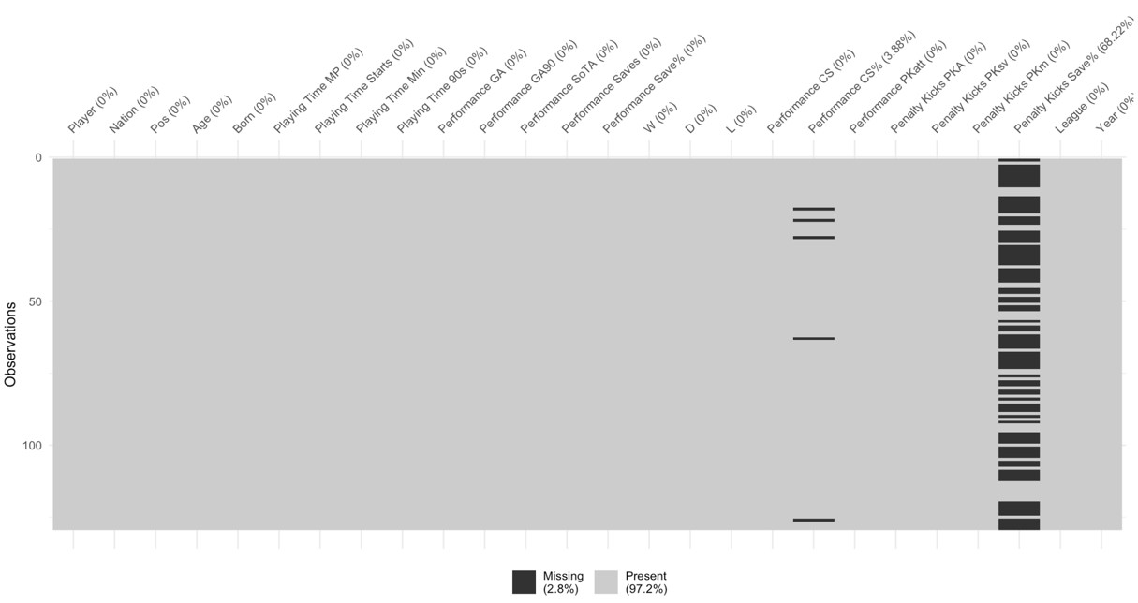

*Figure 8.2: plot of missing for Tournament goalkeeping*

1. **Feature selection for preparation**

Because our sample sizes are small and there are many variables, we first checked the correlations and analyzed the meaning of metrics to reduce the dimensions.

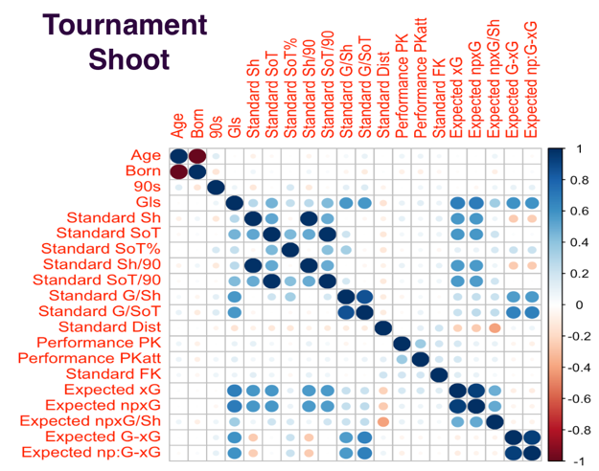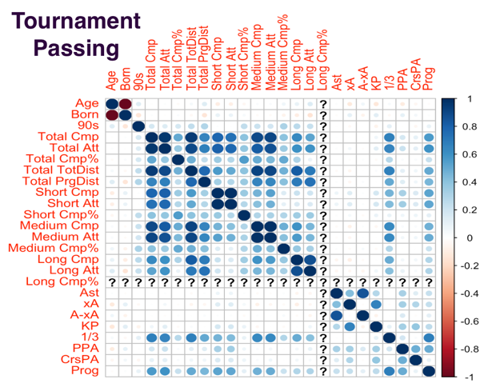

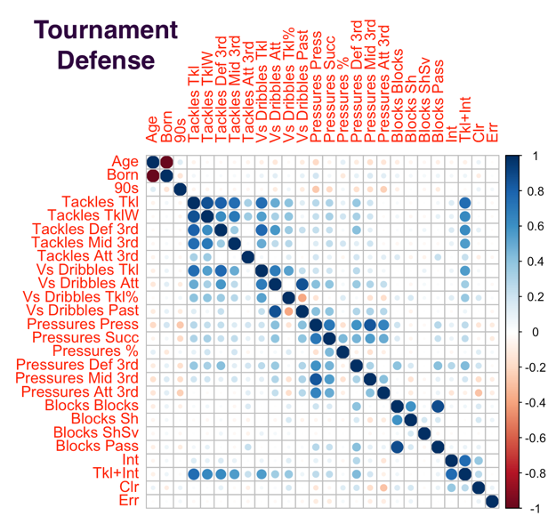

*Figure 8.3: plot of correlations for Tournament data*

Through analysis of correlations and meanings we remove some metrics which have similar representatives with another metric(s) for example: Born and age should both shows a player’s age and they have a perfectly linear relationship which is shown in correlation plots. Therefore we remove the Born and only consider age. For two metrics which shows the similar performance of a player we preferred to keep the one with less missing data. For example Long Cmp and Long Cmp% in passing data, Long Cmp% should be calculated through Long Cmp divided by Long Att by definition; and Long Cmp% has missing data (not the case for Long Cmp and Att) therefore we removed Long Cmp%.

1. **Standardized formula**

Standardized formula (positive index means the higher the better performance, negative index means the lower the better performance):

1. **Entropy weighted method**

The procedures of EWM are following:

Calculate the index’s entropy using standardized :

Calculation of entropy weight:

Overall score by entropy weight method:

Standardized for ShootingFW:

Index’s entropy for ShootingFW:



Entropy weight for ShootingFW:



1. **Expenses and Revenues**

To obtain the inflation rates we used in the project we did the Monte Carlo simulation for it. Following table shows the inflation rates simulated:

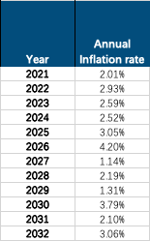

*Table 8.4:predicted inflation rates*

To get the per Capita expenses associated with foreign players, we first applied the linear regression on population. The following graph shows the population of Rarita from 2010-2020 and the fitted line of which the linear regression equation is shown also. We used this equation to estimate the populations of Rarita over 2021-2032.

*Figure 8.5: plot of Rarita’s population and linear regression equation*

*Table 8.6:esitimates of Rarita’s population and predicted expense for foreign players*

To predict expenses for assembling a competitive national the following method is used:

* 1. Calculated the average expenses (total, staff cost and commercial) of top 10 countries in tournament as the expected total football expense for a country which assembles a competitive national team.(in 2020 total expense: ∂279.92, staff cost: ∂189.07,other expense:∂90.85)
  2. Subtracting corresponding Rarita’s original expense (without national team) as the direct expenses of the team.( ∂131.23 in 2020)
  3. Adjusting with adjusting factors (1.1 for first 3 years and 1 afterwards)
  4. Adding expenses on foreign players to get the total (per Capita) team expense
  5. From 2021, each term used in calculation should be derived by multiplying the corresponding term of the last year inflation factor.

*Table 8.7: prediction of expenses*

Revenues are predicted with the similar process with expenses projection. The only difference is that there is no revenue from foreign players.

*Table 8.8: prediction of revenues*

1. **NPV of net income**

According to the chapter 12 of UAM (p.349), the cash flow in a year and be discounted at the rate derived from the yield on government bonds maturing in this year and a single discount rate usually be used to get a conservative valuation. Here we are provided with nominal risk-free spot rate yield curves for different issuance years and maturities. The table 8.9 shows the approximate discount rate should be used for each year. To be more conservative, we used 4.45% (highest) as discount rate in the report.

*Table 8.9: approximate discount rates*

The NPV of net income contains the PV of operating net revenues, one-sum government funding, money borrowed and repayments over the year 2022-2031. The details are shown in table 8.8.



*Table 8.8:NPV of net income of the national team*

**References**

Klugman, S.A., Beckley, J.A., Scahill, P.L., Varitek, M.C. and White, T.A.,

2012. *Understanding actuarial practice*. Society of Actuaries.

“2022 Student Research Case Study Challenge.” SOA,

www.soa.org/research/opportunities/2022-student-case-study/.

1. Inflation rates after 2020 are simulated with Monte Carlo method(Appendix, team selection 2)
2. Note that football players here represents the local players for a country only
3. Based on the team selected, salaries provided and predicted populations of Rarita(Appendix, team selection 2)